**AD110: USER INTERFACE DESIGN - Project 4**

**Statistics Calculator**

**Project Description:**

Create a web page named **statistics.html** and an accompanying external JavaScript file named **statistics.js** that calculates the mean, variance, and standard deviation for a user-entered list of numbers. Here’s what your web page should look like after it first loads and the user enters a list of numbers:

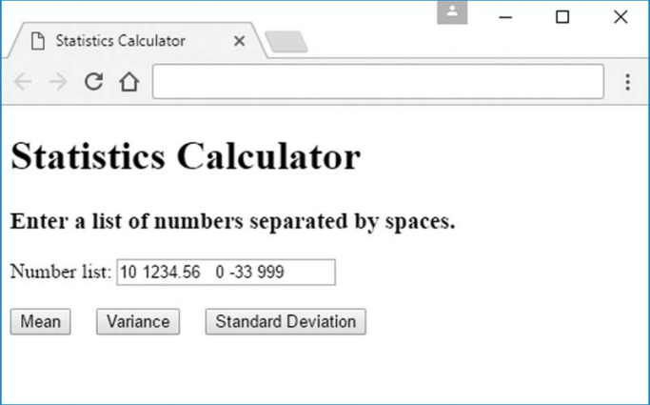

The three buttons should calculate mean, variance, and standard deviation for the user-entered list of numbers, with the result appearing below the buttons. You should perform input validation, making sure that the user enters numbers separated by one or more spaces.

To retrieve numbers from the text control, use the split string method as follows:

array-of-numbers = text-control.value.split(" ");

The split method call parses the text control’s value, saves each space-separated substring as an element in an array, and returns the array.

It’s up to you to display output in an aesthetically pleasing manner. If there’s invalid input, display an error message below the buttons using red text. You must store the array in a NumberList class, and you must implement mean, variance, and stdDeviation methods

Submit your complete summary to **Project 4 in Moodle**.

**FOR INSTRUCTOR USE ONLY**

**Grading Rubric**

*Grading accepts a start value of 100. Points will be deducted for failure to fully complete or meet the stated requirements. Grading: 90-100 = Represents work of superior quality (A); 80-89 = Represents work of good to very good quality (B); 70-79 = Represents adequate command of class content (C); 69 and below = Represents work that shows a need for development or improvement (F); 0 = Represents plagiarized work (F).*

**AD110: USER INTERFACE DESIGN (NCP-WEB)**

**Student:**

**Instructor:**

**Date:**

**Project 4**

|  |  |  |
| --- | --- | --- |
| **Description of requirements** | **Possible Points** | **Your Points** |
| Create a web page named statistics.html and an accompanying external JavaScript file named statistics.js | **20** |  |
| To retrieve numbers from the text control, use the split string method | **20** |  |
| If there’s invalid input, display an error message below the buttons using red text. | **15** |  |
| You must store the array in a NumberList class | **20** |  |
| You must implement mean, variance, and stdDeviation methods | **25** |  |
| **TOTAL** | **100** |  |

**YOUR SCORE**: ________

**Instructor Comments:**